S&M-CM/164/Booster Cards/11-12/ 67 dt @ Chennai-6 the 24.10.2011.
Sub: ISD STVs in Multiple booster facility in 2G/3G Prepaid Mobile services - reg
Ref: S&M-CM/164/Booster cards/11-12/46 Dated @ Chennai -6 the 20-08-2011 and 14-10-11 and 17-10-11

In continuation to the above referred letters, it is intimated that *124*2# can be used to know the information about the ISD STV in use and its validity, in Grp V.
This is for the information of all please.
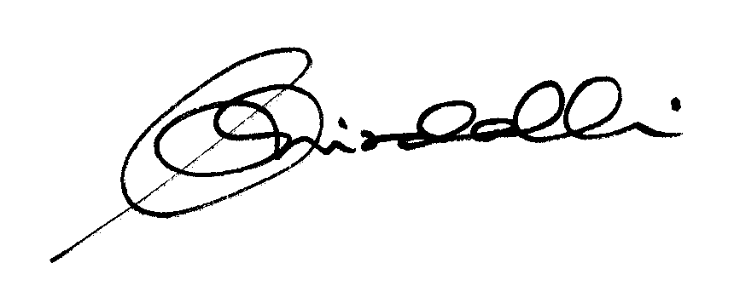

(K.R. Aravindavalli)

AGM(Marketing-CM)

TN Circle

To

GM (NW-O CM), Trichy -1/ Coimbatore – For information please.
GM(S&M-CM), Chennai Telephones, Chennai – For information please.
GM (F) / Sr. GM (TR) TN Circle, Chennai for information please.
DGM/DE IN Incharge - Trichy - for information & necessary action please.
DGM (N/W Ops-CM)/DE Commercial -Coimbatore - For information & necessary action please.
Heads of SSAs, -- for kind information and necessary action please.
DGM (Sales) & AGM (Sales), Chennai-6 –For information and informing Sales Heads , franchisee managers and retail managers and other Channel partners along with commission structure as applicable.
DGM (CS), Chennai-6 - For information and informing Call Centre/Customer Service Centre Officials and ensure uploading the information on the website “tamilnadu.bsnl.co.in” .
DGM(S&M-CM)/AGM (Mktg-CM), Chennai Telephones, Chennai – for information & necessary action please.

